Unloop Full Stack Web Development

Intro to Front-End Frameworks (w3) Lab

## **Introduction**

**What is a “framework?”**

A framework is a standardized set of concepts, practices and criteria for dealing with a common type of problem, which can be used as a reference to help us approach and resolve new problems of a similar nature.  
  
In the world of web design, a framework is defined as a package made up of a structure of files and folders of standardized code (HTML, CSS, JS documents etc.) which can be used to support the development of websites, as a basis to start building a site.  
  
Most websites share a very similar (not to say identical) structure. The aim of frameworks is to provide a common structure so that developers don’t have to redo it from scratch and can reuse the code provided. In this way, frameworks allow us to cut out much of the work and save a lot of time. **Aka there’s no need to reinvent the wheel!**

Frameworks come in all shapes and sizes and can be used across your “tech stack.” The main distinction between frameworks is between the front-end (visuals) and backend (application and data services.) The w3 framework is in the front end layer! See the below diagram for some examples.

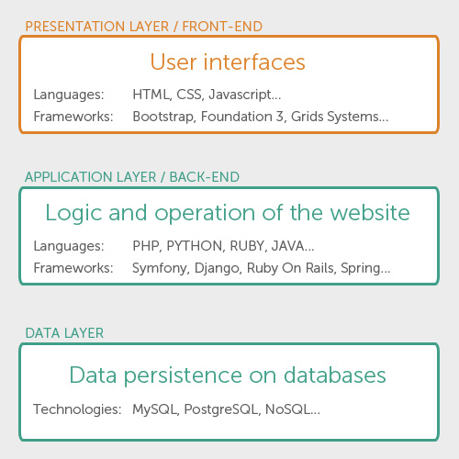

Advantages and disadvantages of using frameworks

**Advantages**

* Speeds up the mock-up process
* Clean and tidy code
* Solutions to common CSS problems
* Browser compatibility
* Learn good practices
* Having a single procedure to resolve common problems makes maintaining various projects more straightforward.
* Helpful in collaborative work

**Disadvantages**

* Mixes content and presentation
* Unused code leftover
* Slower learning curve
* You don’t learn to do it yourself

**Is it advisable to *always* use a framework?**  
Not necessarily. The developer must take the final decision on whether or not to use a framework. This will depend on several of the issues we’ve looked at. Frameworks are a resource that can be extremely useful for many people, but that doesn’t mean they are necessarily useful for you. Now you know what they are, which ones are out there, and the advantages and disadvantages of using them.

## **Lab Instructions**

**Learning Objective:**

* Familiarize concept and benefits of front end web frameworks!
* Gain experience using and customizing styles from w3 framework.
  + W3-buttons
  + W3-sidebar
  + W3-blockquote
  + W3-text
  + W3-layout
  + And more!
* Gain experience with introductory JavaScript code.

**Objective:** In this lab, you will be modifying the provided mobile website that uses the w3 framework.

**How to begin:**

Reading the documentation:

1. [W3.CSS Home](http://www.w3schools.com/w3css/default.html)
2. [W3.CSS Intro](http://www.w3schools.com/w3css/w3css_intro.html)
3. [W3.CSS Templates](http://www.w3schools.com/w3css/w3css_templates.html)
   1. Demo at least one template.
   2. View the code for at least one template. Alter the code and view the changes.
4. [W3.CSS Case](http://www.w3schools.com/w3css/w3css_case.html)
   1. View the example code at each step of the tutorial.

Gathering the files

1. Copy the folder named “tech_blog” from the Labs folder on the classroom drive.
2. Paste the folder named “tech_blog” into *your* labs folder.
3. Look through the provided files!
   1. Note that you have been given the following:
      1. index.html file
      2. Necessary images
      3. Frameworks folder containing a file named “w3.css”

Note that there is NO custom stylesheet file! :o That is because the w3 framework does all the heavy lifting for us.

1. For every web page that uses the w3 framework, you must link to the resource (just like any other CSS file!) In your HTML’s <head> section, include the w3 framework by pasting the following line into the provided “index.html” file’s <head> section:  
   **<link rel="stylesheet" href="frameworks/w3.css">**

**(Note: the href is a relative link that will depend on the location of the current html file)**

1. Save your files and view the website in your browser. Use Google Developer Tools to view the website on different devices. (The following screenshots are rendered on an iPhone 6)

**Continue past the screenshots for more instructions...**

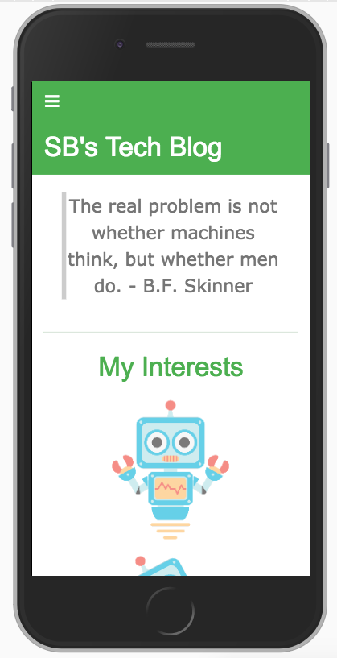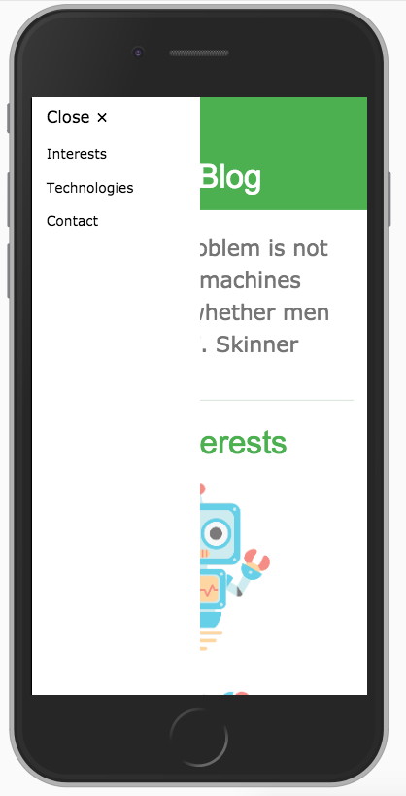

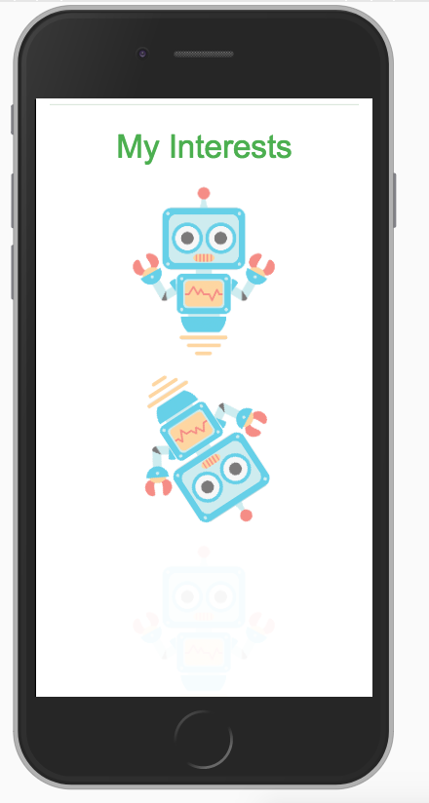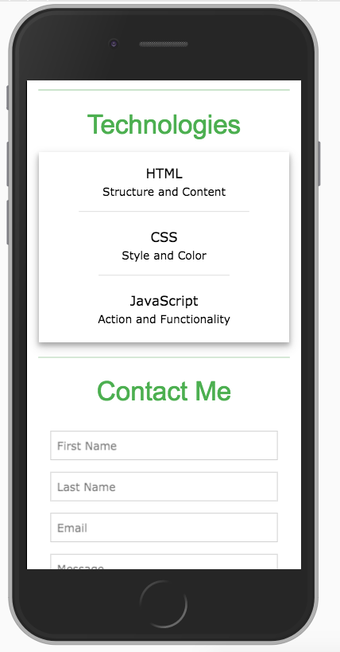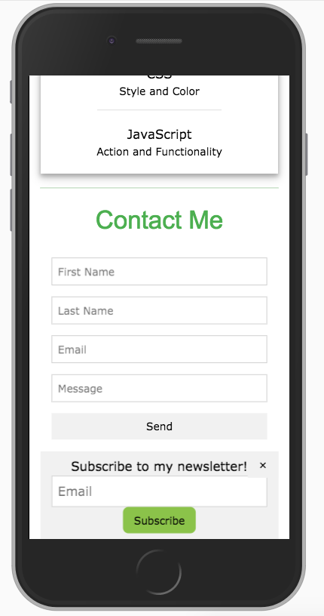

**You must make the following changes to the website by using the classes provided by the w3 framework:**

1. Change the *content* of the website to exhibit more of your personality. This must include:
   * Change the “title” of the page. (Text should not be “SB’s Tech Blog”)
   * A quotation of your choice in the blockquote tag.
   * Replace the 3 images of robots with images of your choice.
     + Note: they will look best if they are approximately the same height and width.
2. Change the background color of the “Navigation Content” section.
   * See: [W3 CSS Colors](http://www.w3schools.com/w3css/w3css_colors.html)
3. Change the color of the section header text.
   * See: [W3 CSS Colors](http://www.w3schools.com/w3css/w3css_colors.html)
4. Animate the three images!
   * See: [W3 CSS Animations](http://www.w3schools.com/w3css/w3css_animate.html)
5. Make the size of the text in the navigation sidebar larger.
   * See: [W3 CSS Fonts](http://www.w3schools.com/w3css/w3css_fonts.html)
6. Add *at least* one component to your web page that utilizes a w3 framework property. Some ideas include:
   * [Dropdown menu](http://www.w3schools.com/w3css/w3css_dropdowns.html)
   * [Table](http://www.w3schools.com/w3css/w3css_tables.html)
   * [Photo Effects](http://www.w3schools.com/w3css/w3css_effects.html)
   * [Badges](http://www.w3schools.com/w3css/w3css_badges.html)

Note: some of the functionality may include JavaScript to work. Feel free to copy the code from the examples into your code OR sit tight until we get to JavaScript fundamentals as a class.

Debugging:

7. Using Google Developer tools, determine why the “JavaScript” list item in the “Technologies” page section is not underlined, unlike the list items before it.

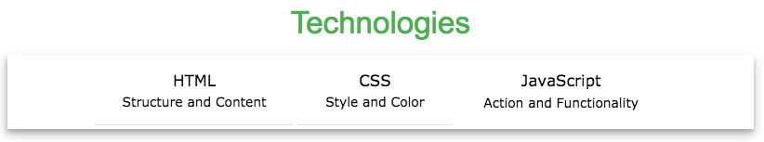

>> How would you customize this styling?